**Exploring the Environment**

Waleed Afzal

FAST NUCES – CFD Campus

SS2019: Psychology

Anoosha Rehan

October 11, 2024

**Positive Pictures (5 Pictures):**

**Pic # 1:**

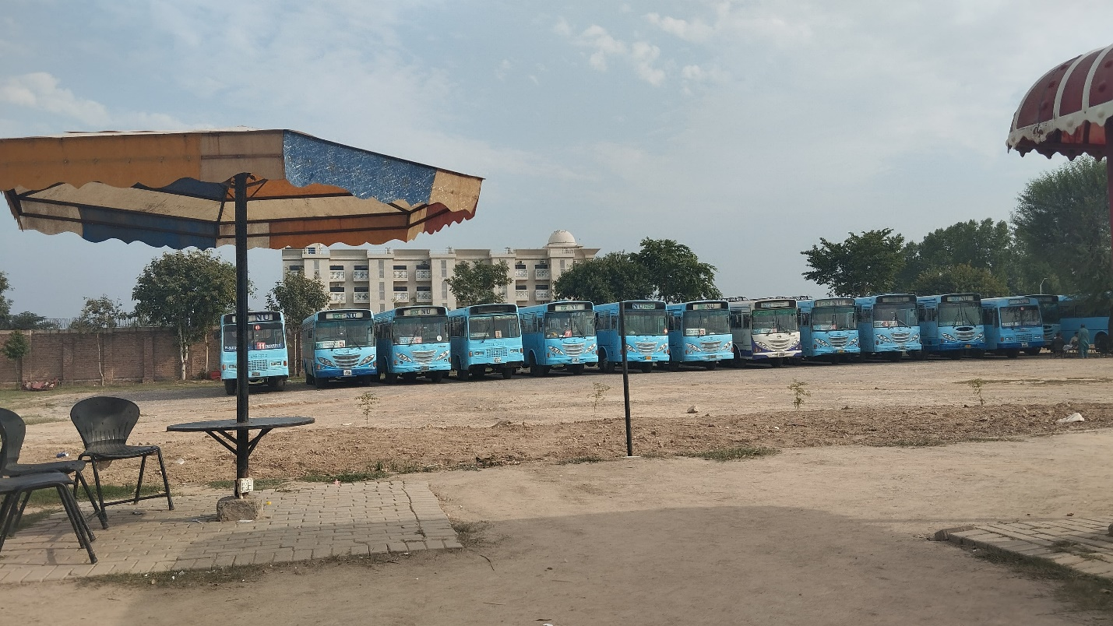8/October/2024

Fast NUCES – CFD Campus  
4:53 PM

**Description**: The university is doing a great job by providing bus services for students who live far away. This helps them save time, money, and makes travel to campus easier and more comfortable.

**Pic # 2:**

8/October/2024

Fast NUCES Boys Hostel GYM – CFD Campus  
6:13 PM

**Description**: The gym facility in the hostel is a great addition, helping students stay physically active and healthy. It allows them to maintain fitness and build smart habits while focusing on their studies.

**Pic # 3:**

8/October/2024

Fast NUCES Boys Hostel Mosque – CFD Campus  
7:45 PM

**Description**: The praying area in the hostel is a nice space for students to pray and connect with God. It helps them reflect and find peace, and students who pray often show good values.

**Pic # 4:**

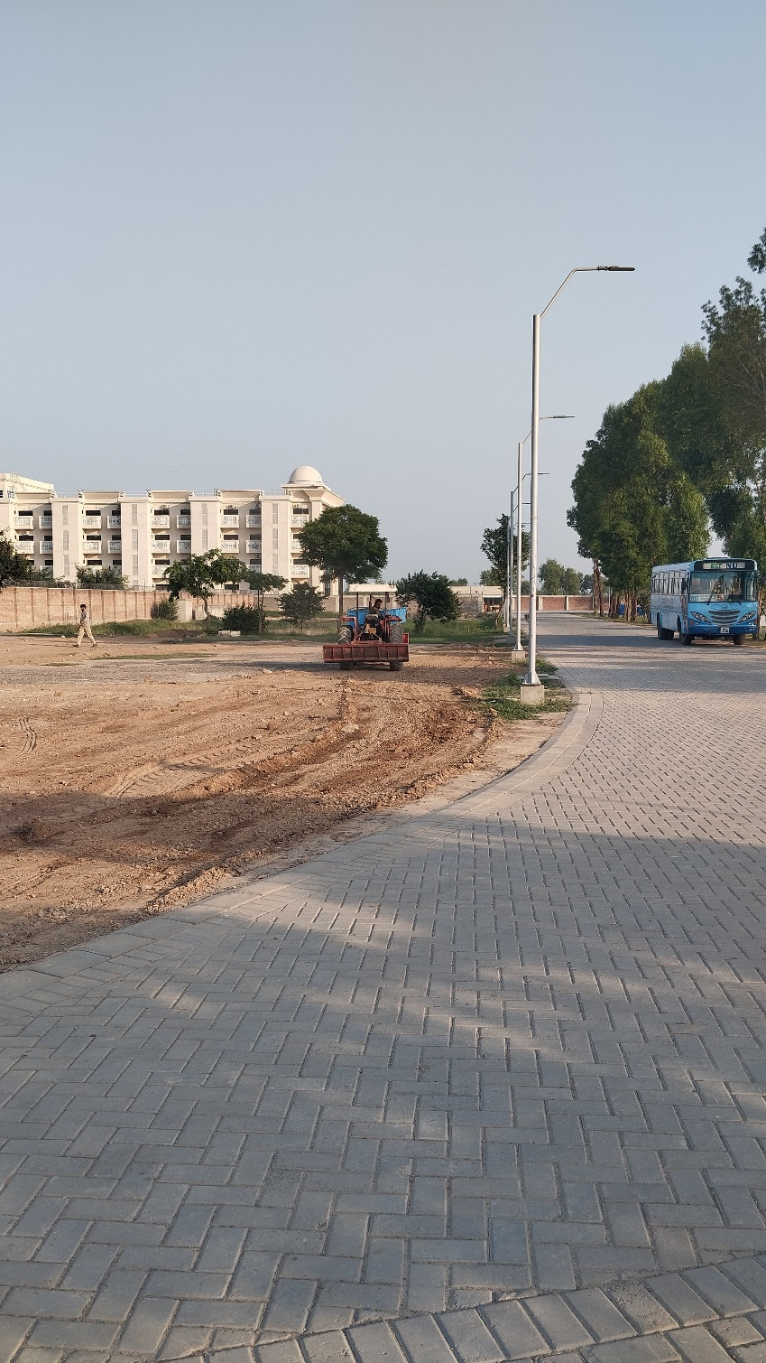

7/October/2024

Fast NUCES – CFD Campus  
3:16 PM

**Description**: The university is preparing to plant trees to give students fresh air and reduce pollution. This will not only improve the environment on campus but also benefit society.

**Pic # 5:**

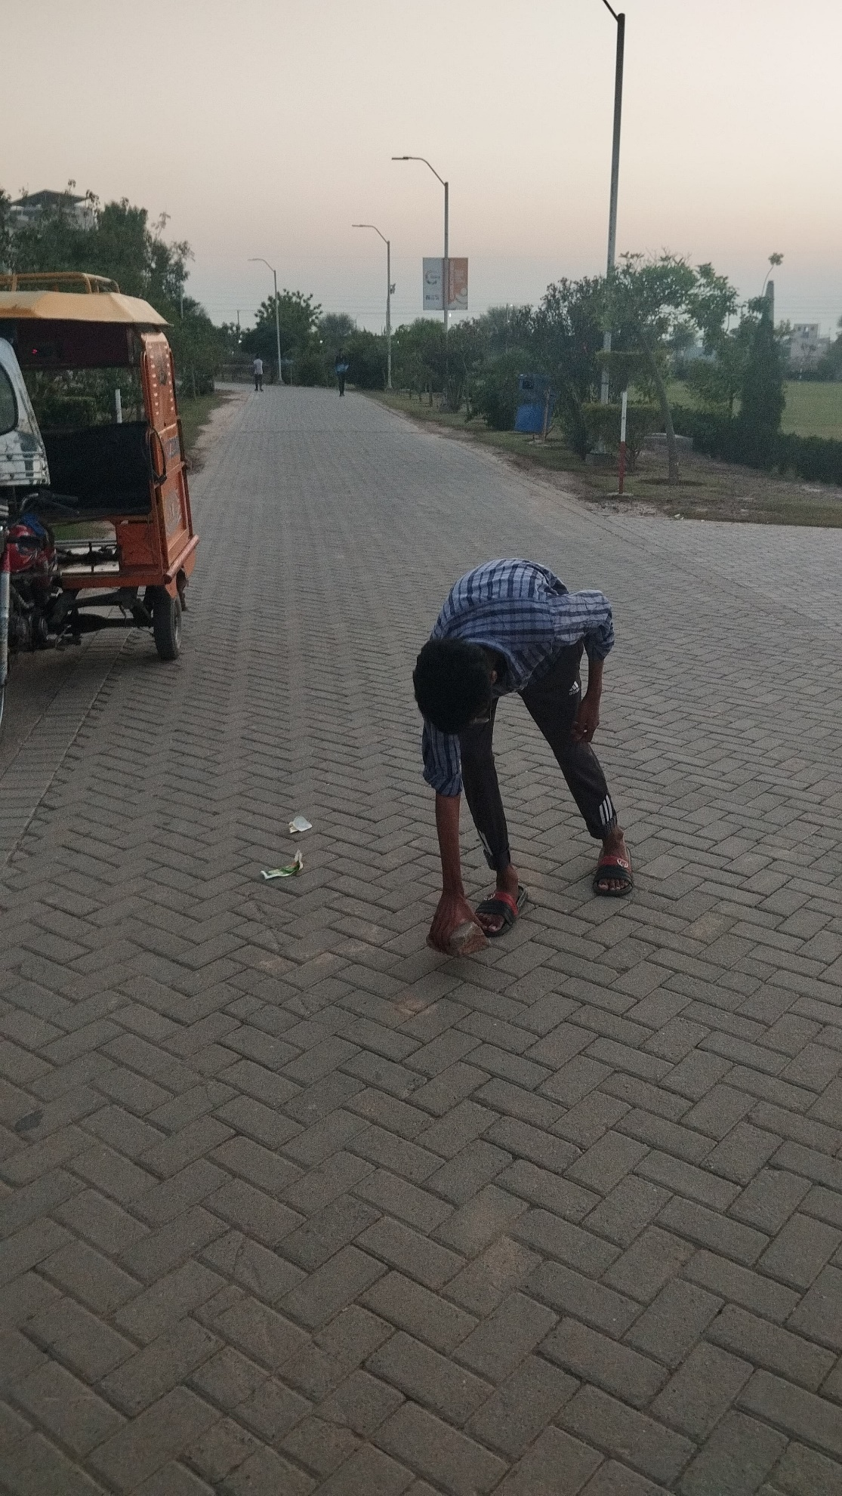

7/October/2024

Fast NUCES – CFD Campus  
6:44 PM

**Description**: Clearing rocks or obstacles from the path is a positive action that benefits everyone. It helps make the way safer and easier for others, contributing to the well-being of the community.

**Negative Pictures (5 Pictures):**

**Pic # 1:**

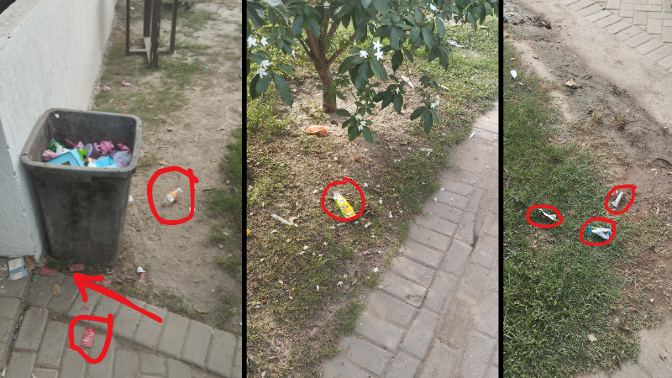

8/October/2024

Fast NUCES Dhaba – CFD Campus  
7:25 PM

**Description**: Not throwing waste in the dustbin is harmful to society. It creates pollution and makes the environment dirty. Everyone should use dustbins to keep the surroundings clean.

**Pic # 2:**

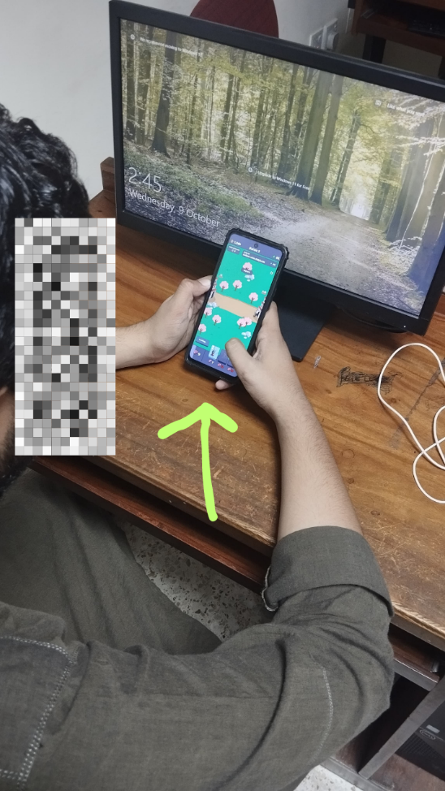

8/October/2024

Fast NUCES Lab – CFD Campus  
3:15 PM

**Description**: Instead of studying in the lab, the boy is playing games, which is not good for him. He doesn't realize that it's affecting his learning and future.

**Pic # 3:**

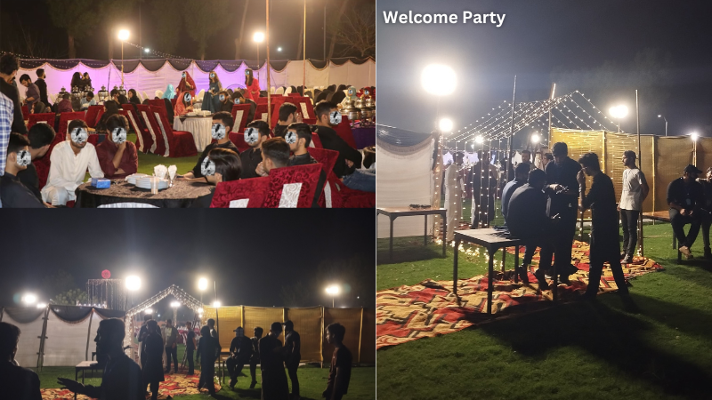

3/October/2024

Fast NUCES – CFD Campus  
8:40 PM

**Description**: The welcome party disturbed the students living in the hostel, making it hard for them to study. The noise affected their focus and caused discomfort.

**Pic # 4:**



5/October/2024

Home   
1:20 PM

**Description**: Kids using mobile phones for a long time can harm their mental health and eyesight. Parents should control screen time to protect their children's well-being.

**Pic # 5:**

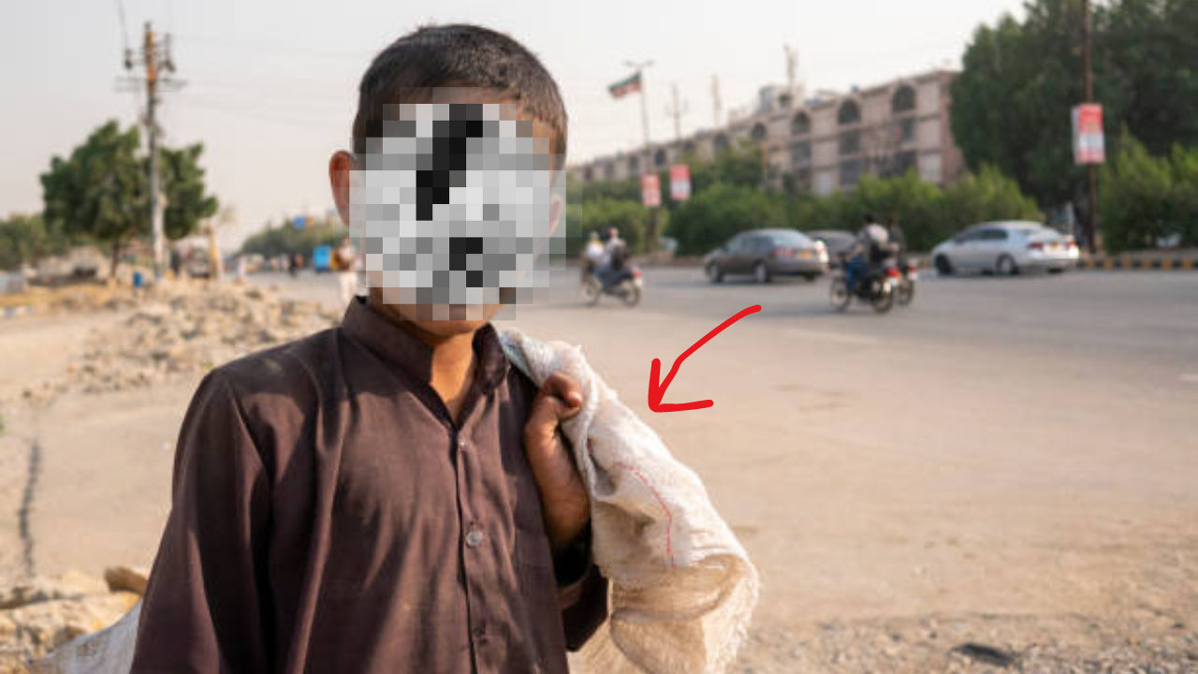

10/October/2024

Kohinoor Plaza Faisalabad   
5:47 PM

**Description** Kids doing labor work is harmful because it is not suitable for their age. However, due to poverty, they have no choice but to work to support their families.